Acceptance test
Should be able to see statistics of both protein sequence and nucleotide
Acceptance criteria
Statistics.java and proteinStatistics.java should execute properly without any errors

User open main window
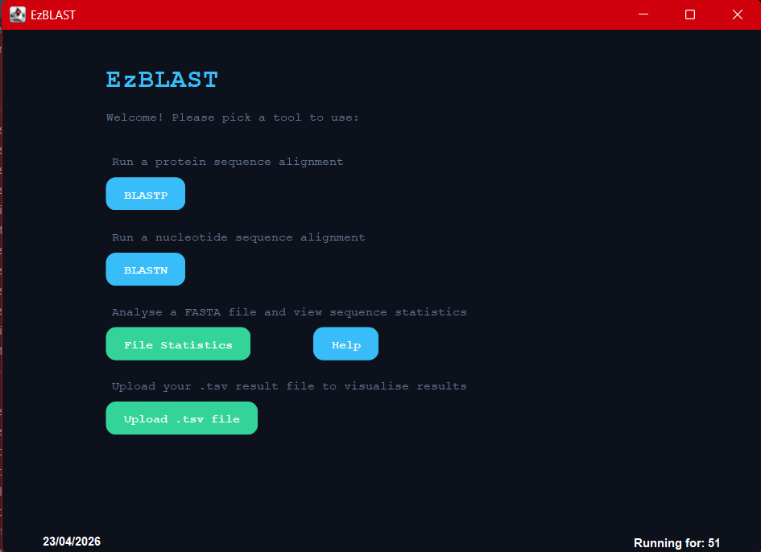
User open file statistics and select protein or nucleotide file
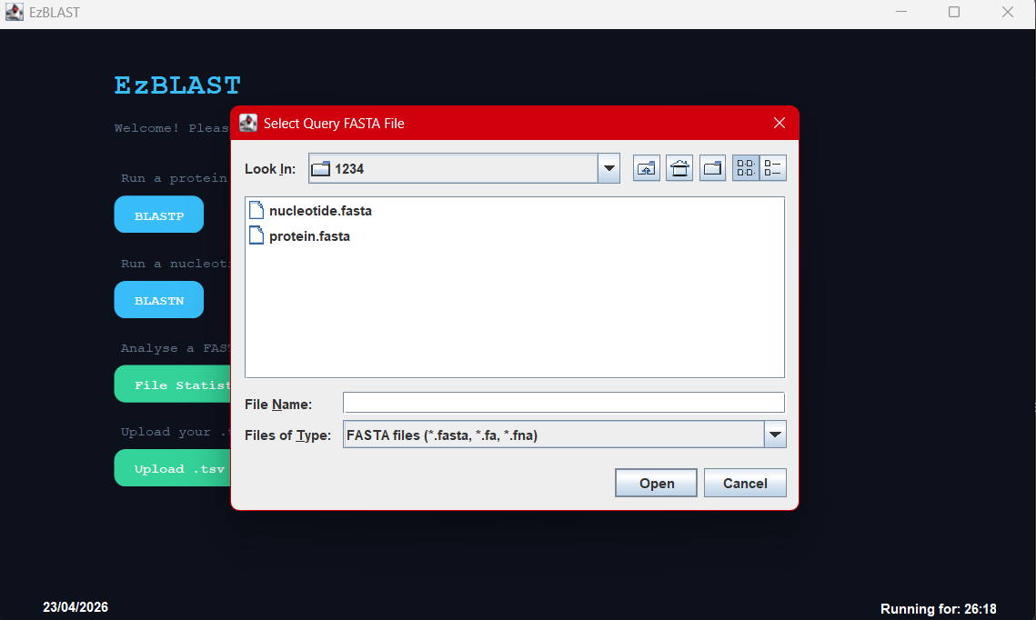
Statistics result for nucleotide file
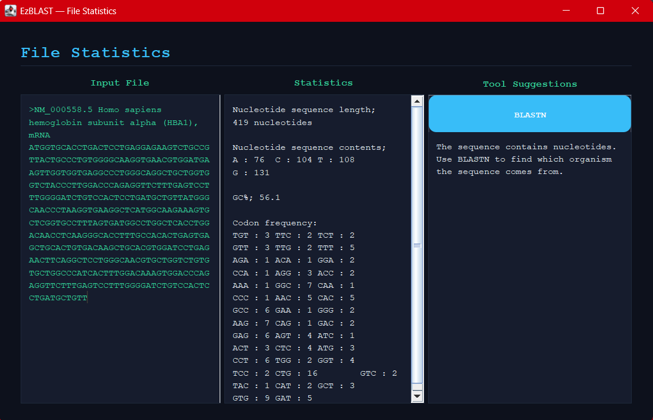
Statistics result for protein file
